Disclaimer
The folks at Carbon Sense are not making predictions about what will happen in Venezuela, nor arguments about what should. We are simply running the numbers.
Venezuela’s oil reserves are a national asset, and it is entirely legitimate for Venezuelans to seek economic recovery after years of hardship. This analysis does not argue that Venezuela should be treated differently from other resource-rich countries or denied development opportunities.
Instead, we use scenarios to explore what could happen under different investment pathways and what those pathways imply for emissions and global warming. The goal is not advocacy, but clarity: understanding how capital investment, production economics, and climate constraints interact once oil infrastructure is built.

Introduction
On the night of Friday 2nd of January, the United States stunned the world by capturing Nicholas Maduro, the sitting President of Venezuela, in a raid in Caracas. We will leave the ramifications on geopolitics and international law to others that understand far more than us at Carbon Sense.

However, a central part of the United States’ motivation for removing Maduro is Venezuela’s oil reserves. Data say they are the largest of any country on the planet and Donald Trump has urged oil companies to invest $100bn. While this has also been widely commented on, in this article we focus on a less discussed reverberation: the potential impact of the United States’ recent actions on climate change.

Whilst Venezuela does have the world’s largest oil reserves, reserves alone cannot heat the planet. Venezuela’s experience is often discussed through the lens of resource curse: abundant natural resources have undermined, rather than promoted, long-run economic growth, political institutions, and social welfare. In practice, its production collapse reflects a more specific mix of political intervention, international sanctions, and investment instability.

Some analysis has suggested that the United States’ plans to exploit Venezuela’s oil could alone account for 13% of the remaining carbon budget to keep warming to 1.5℃. This article seeks to provide clarity on claims such as these, and highlight the global warming potential of Venezuela’s reserves.

While Venezuela has vast reserves, it produces relatively little
While the Middle East often comes to mind when thinking of oil stocks, it is actually Venezuela that has the largest proved oil reserves. In principle, ‘proved’ oil reserves are those that can be extracted with at least 90% probability under current economic and technical conditions.

The figure below, based on data from the Energy Institutes’ 2025 Statistical Review of World Energy, shows the ten countries with the largest provided oil reserves. Venezuela has more oil than Saudi Arabia and more than Iran and Iraq combined. These reserves account for 18% of the global total.

Figure 1: Venezuela’s proved oil reserves are the largest in the world
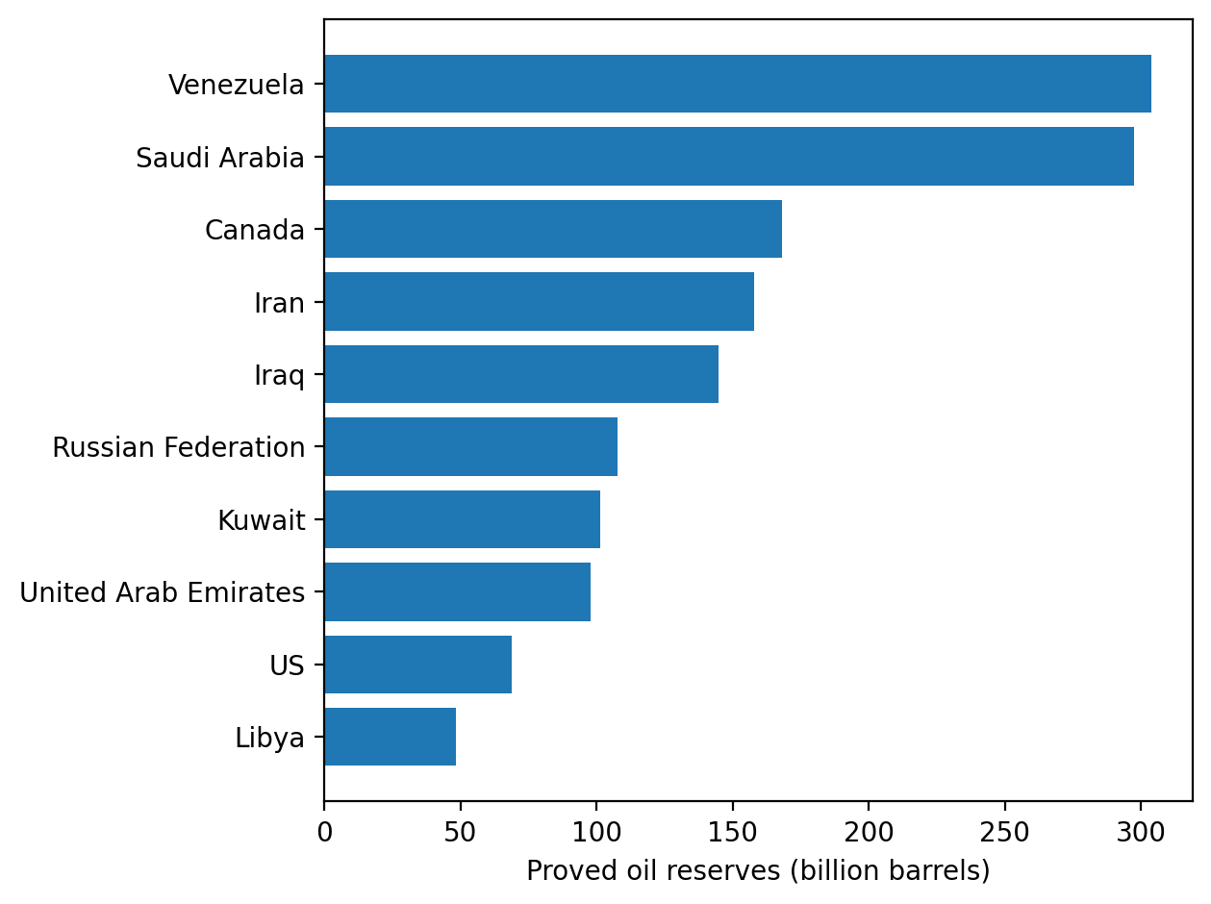
Source: Energy Institute, Statistical Review of World Energy (2025). Notes: data are for 2020 (the most recent year for which the Energy Institutes has published proved reserves data).

Venezuela did not always hold this mantle. Between 2006 and 2013, parts of its Orinoco Belt were reclassified as proved reserves - see Figure 2 below. However, it is important to note they remain “heavy” or “extra heavy”, which has two implications.

First, such crude is significantly more expensive to extract and process than conventional oil. Its dense, tar-like consistency means it does not flow naturally and often requires dilution, upgrading, or energy-intensive recovery techniques. As a result, production from the Orinoco Belt is highly dependent on oil prices and investment conditions: when prices are low or capital is scarce, projects quickly become uneconomic.
Here, it is worth dwelling on what ‘proved’ oil reserves really are. In principle, as mentioned above, they are deposits that can be extracted with at least 90% probability under current economic and technical conditions. As the crude in the Orinoco Belt can quickly become uneconomic under certain conditions, some analysts argue that the share of Venezuela’s ‘proved’ reserves that is economically recoverable under realistic conditions may be smaller than headline figures suggest. That said, even if a share of the Orinoco Belt reserves cannot be extracted under current conditions, Venezuela would continue to hold substantial reserves.
Second, heavy and extra heavy crude require significantly more energy to extract, transport, and refine into usable fuels. This makes Venezuela’s oil among the most carbon-intensive in the world. According to industry estimates from S&P Global Platts Analytics, upstream emissions from Orinoco Belt crude are around 1,460 kg CO₂e per barrel of oil equivalent. This is almost 1,000 times higher than the world’s least carbon intensive reserves, such as Norway’s Johan Sverdrup field (about 1.6 kg CO₂e/boe).

Figure 2: The increase in proved oil reserves in Venezuela is driven by the Orinoco Belt
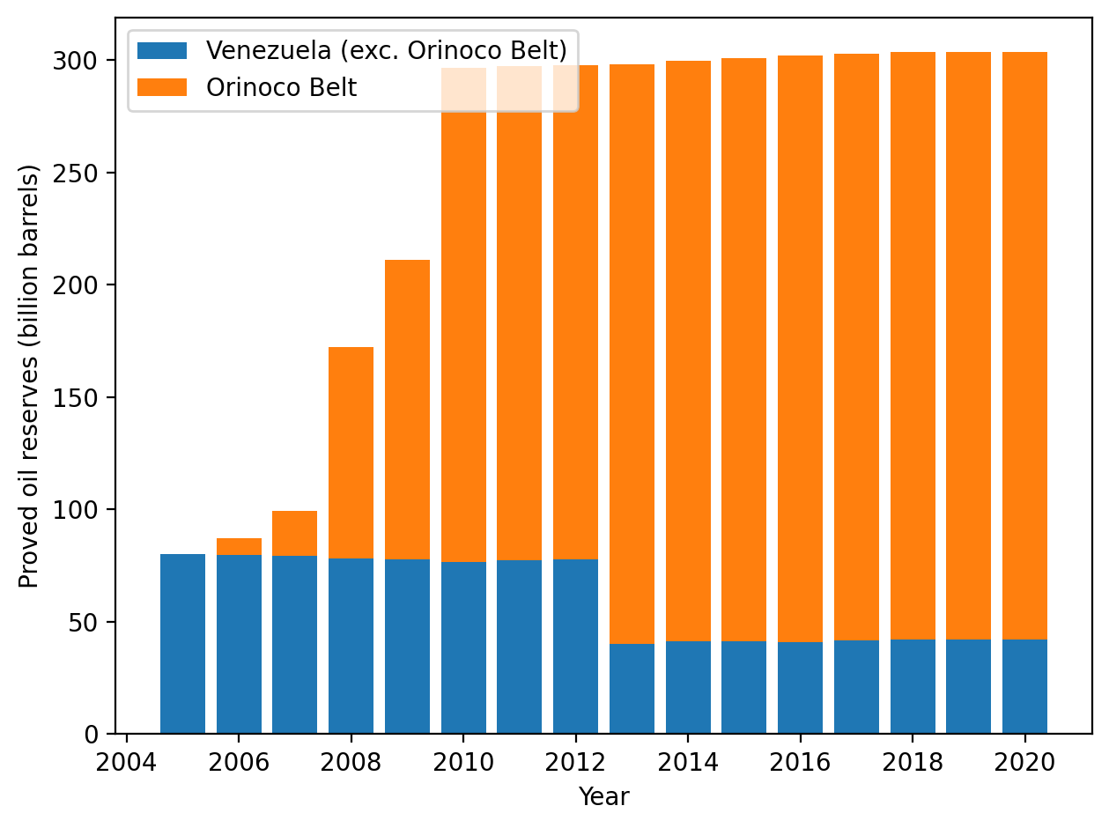
Source: Energy Institute, Statistical Review of World Energy (2025).

Despite its reserves, Venezuela produces relatively little compared to other oil-rich countries. The figure below shows that in 2020 Venezuela produced only around 5% as much oil as the United States, as well substantially less than other countries with smaller proved reserves. This production accounts for just 1% of the global total.

Figure 3: Venezuela produces relatively little compared to other countries
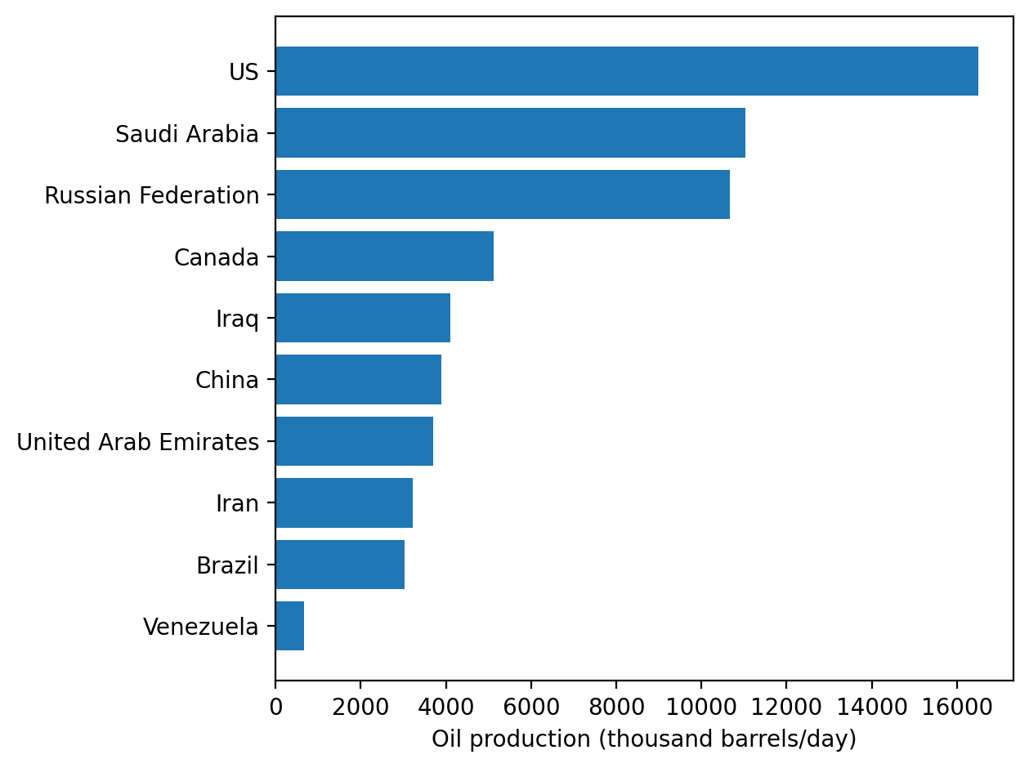
Source: Energy Institute, Statistical Review of World Energy (2025). Notes: data are for 2024 (the most recent year for which the Energy Institutes has published production data).

Combining proved reserves and current production gives the ‘reserves-to-production ratio’ (R/P ratio). In simple terms, it measures how many years a country’s proved oil reserves would last if production stayed constant and no additional reserves became economically viable. Those are, of course, very strong assumptions, but the results are revealing nonetheless.
As shown in Figure 4 below, Venezuela’s R/P ratio is exceptionally large because it combines an enormous proved reserves base with low production. In 2020, a trough for Venezuelan output, Energy Institute data suggest an R/P ratio of over 1,000 years.
This stands in sharp contrast to countries like the United States, whose R/P ratio is much lower, around a decade, not because it is about to exhaust its oil resources, but because it produces large volumes continuously while replenishing proved reserves through ongoing exploration, investment, and technological change.
The comparison highlights a fundamental divergence: Venezuela has an enormous proven resource base that is not being translated into production, while the US and other countries operate a high-throughput oil system in which reserves and production move together.
Figure 4: Venezuela produces little compared to its proved reserves
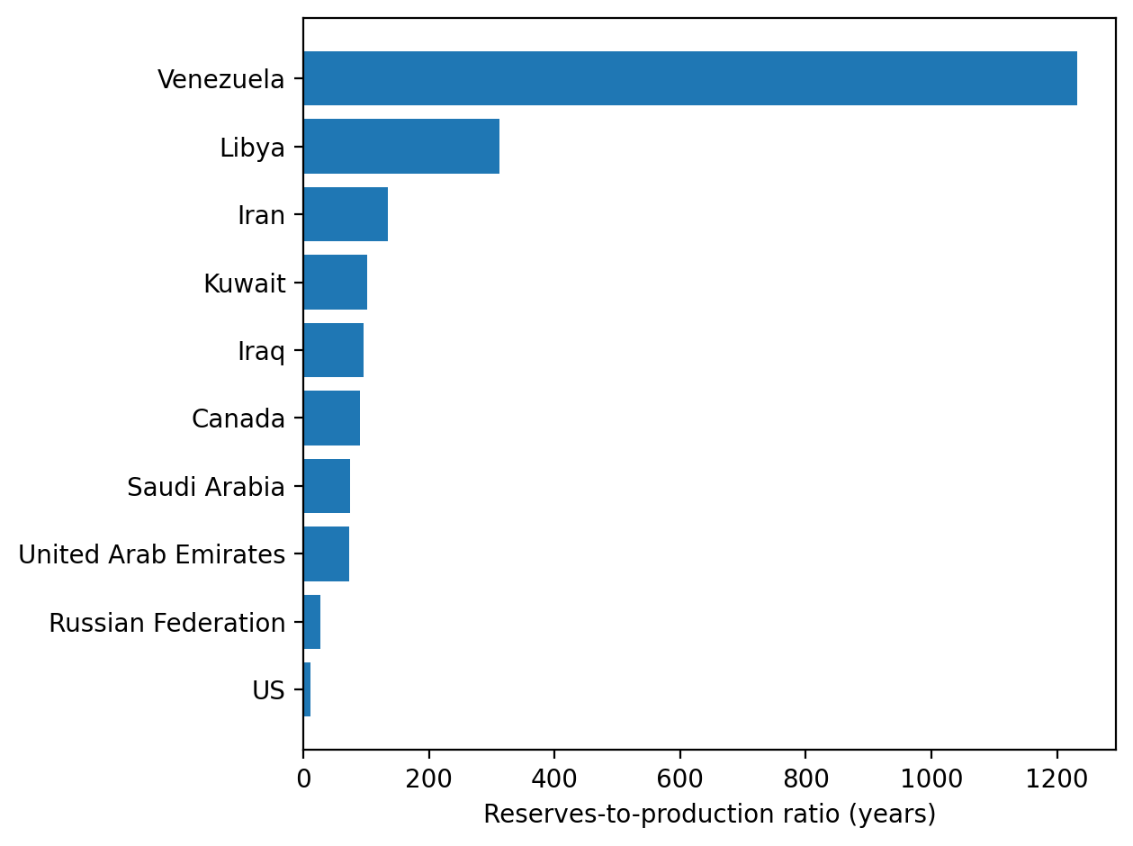
Source: Energy Institute, Statistical Review of World Energy (2025). Notes: data are for 2020 (the most recent year for which the Energy Institutes has published proved reserves data).

Figure 5 places Venezuela’s current production levels in historical context. It shows that the country’s oil output has not been constrained by geology but rather by changing politics. Three distinct phases stand out.
- During the final years of the Punto Fijo era in the 1990s, Venezuelan oil production increased year-on-year to a peak of 3.5 million barrels per day (shown in blue on the figure). During this period, the state oil company PDVSA and private operators had relatively strong technical capacity and infrastructure in place, supported by foreign investment.

- During Hugo Chávez’s presidency, from 1999 to 2013, oil production remained over 2.7 million barrels per day. Chávez’s policies nationalised large parts of the oil sector, transferring control of major projects from foreign operators to the state and political appointees, while investment in maintenance and exploration increasingly fell behind. Several of these transfers later became the subject of international arbitration claims by United States and European oil companies, many of which were upheld. This legacy of legal uncertainty continues to weigh on investor confidence and on the willingness of international firms to return.

- Under Nicolás Maduro, oil production collapsed to only 0.7 million barrels per day in 2020, before covering slightly. Deep underinvestment and maintenance neglect weakened infrastructure further, while United States sanctions restricted the export of oil. The heaviness of Venezuela’s crude oil, noted above, also helps explain this decline: unlike lighter grades, production requires continuous investment in infrastructure; without it, production declines are steeper and recovery more costly.

Figure 5: The rise and fall of Venezuelan oil production
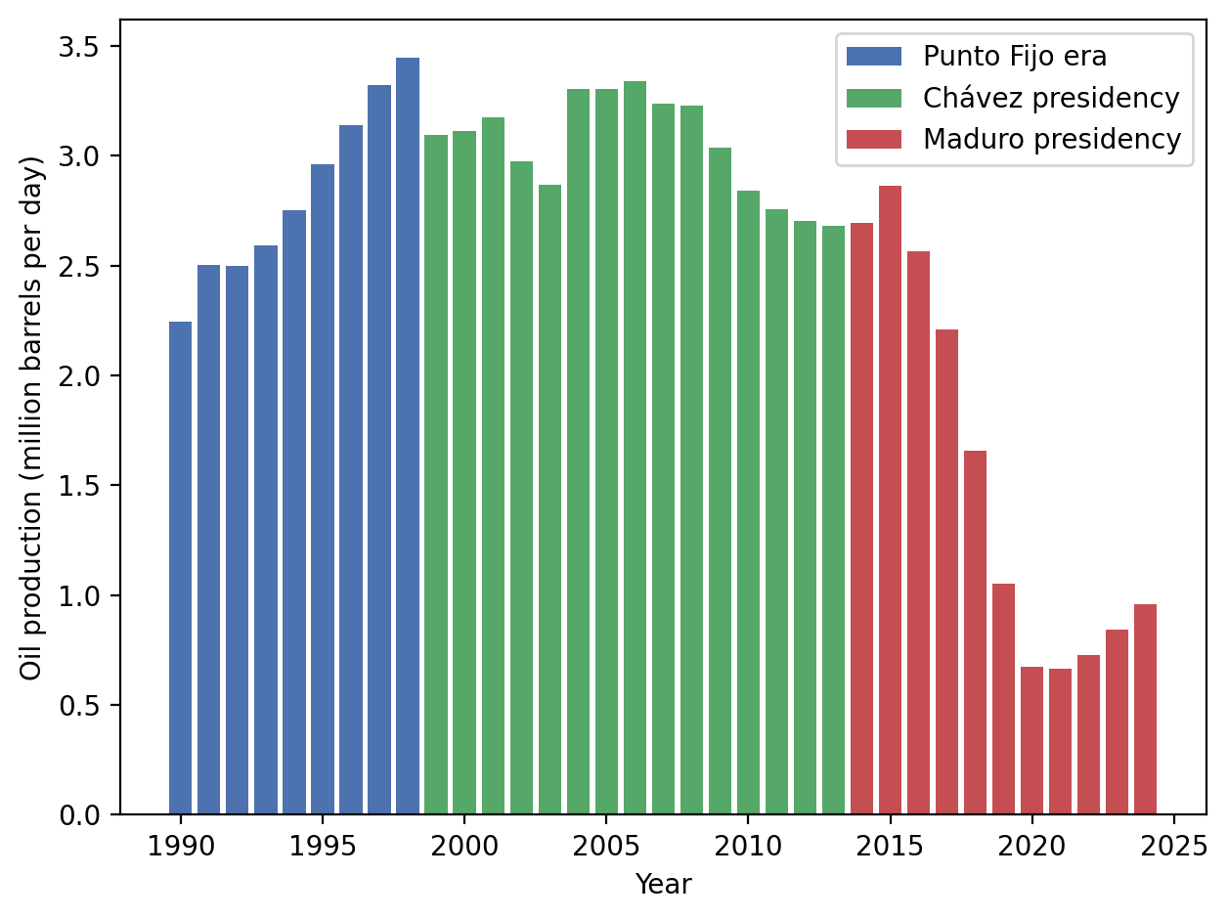
Source: Energy Institute, Statistical Review of World Energy (2025).

So what does this all mean? Is Venezuela sitting on a ticking time bomb?
Of course, it is important to stress that what happens next in Venezuela’s oil sector is deeply uncertain. Production outcomes will depend on a complex mix of factors, including political uncertainty, investor confidence, the state of existing infrastructure, and conditions of global oil markets.

Rather than offer a forecast, we therefore consider four illustrative scenarios intended to capture plausible potential outcomes, from continued stagnation to a large-scale revival of Venezuela’s oil sector. These scenarios reflect different assumptions about the pace and scale of investment, institutional reform, and infrastructure recovery that are already being discussed by policymakers, analysts, and the media.

Our approach in these scenarios is deliberately simplified. We anchor production at today’s levels and then specify alternative paths for future evolution. In each case, we assume that any increase in Venezuelan production above today’s level translates into additional oil ultimately consumed globally and estimate the associated emissions and warming impact. That is, additional production in Venezuela does not displace the output of other producers but is instead additional.

These are strong assumptions but they serve a clear purpose. They allow us to isolate the potential climate consequence of expanding production in Venezuela, without layering in the speculative dynamics of oil prices, demand responses, OPEC behaviour, or displacement of other producers.

Taken together, these scenarios span outcomes that range from constrained continuity through modest recovery to increasingly ambitious (and potentially less likely) expansion paths, informed by recent industry analysis and reporting. Full details of the production paths and subsequent calculations are set out in the annex.

Scenario 0: Status Quo
This is the world we already know. Investment remains scarce, production limps along at roughly today’s level, and Venezuela’s vast reserves stay largely untouched. In fact, some reporting suggests that Venezuelan production may fall below current levels in the near term. Factors such as continued export restrictions, low international investor confidence following previous transfers of control, and shortages of naphtha used to dilute heavy crude could push output lower absent political resolution.
From a climate perspective, this is the least dramatic outcome. Emissions are real, but modest relative to proved reserves. Most of the oil remains underground, not because of deliberate climate restraint, but because the investment and political conditions required to extract it simply are not in place.
Averaged over the period from now to 2050, this level of production translates into around 0.9 GtCO₂ per year in emissions — roughly equivalent to co-author Andrew flying home from Europe to New Zealand 430 million times a year. Using standard IPCC estimates, that equates to 0.01°C of warming over the period.
That is not nothing. But relative to Venezuela’s geological endowment, it is barely a rounding error. In this scenario, most of the country’s oil, and potential emissions, remains underground. The climate outcome here is shaped less by policy choice than by circumstance: scarce investment, degraded infrastructure, and a political environment that has kept production stuck well below its historical peak.

Scenario 1: Modest but Sustained Recovery
This represents a cautious recovery, based on analysis from ClimatePartner. In this world, investment returns slowly. Production rises by around 0.5 million barrels per day by 2028, before reaching roughly 1.6 million barrels per day above today’s level by the mid-2030s, where it then stabilises.

This path still falls well short of Venezuela’s historical production peak in the 1990s but marks a clear break from stagnation. It is consistent with a sanctions relief, renewed access to diluents, selective foreign investment, and incremental repairs to existing infrastructure — without assuming a wholesale transformation of the sector or a surge to historic highs.
Averaged over the period to 2050, this scenario adds around 0.9 GtCO₂ per year. Put differently, now Andrew is flying home about 860 million times a year. Cumulatively, and again using standard IPCC estimates, this equates to a further 0.01°C of warming between now and 2050.
Despite its modest scale, this scenario would absorb 13% of the remaining carbon budget consistent with limiting warming to 1.5°C. The lesson is subtle but important: even a relatively restrained recovery, if sustained over decades, can carry significant climate consequences in a world with very little remaining headroom.

Scenario 2: Significant Recovery
In this world, capital returns more decisively and institutional conditions improve enough to support large-scale reinvestment. Infrastructure is repaired, skilled labour returns, and production steadily recovers. By 2035, output rises from today’s roughly 1.1 million barrels per day back toward Venezuela’s historical peak of around 3.4 million barrels per day (see Figure 5 above).
Averaged over the period to 2050, this scenario adds around 1.3 GtCO₂ per year - equivalent to Andrew making the journey home about 1.47 billion. Cumulatively, this translates into roughly 0.015°C of additional warming between now and 2050 and would consume around 19% of the remaining carbon budget consistent with the 1.5°C target.
This is the point where sunk capital begins to dominate the story. Once wells are drilled and pipelines laid, fixed costs are already paid and marginal extraction costs fall sharply. Each additional barrel becomes relatively inexpensive to produce even as its climate costs remain unchanged. At that stage, responding to climate signals becomes more difficult. This lock-in effect means that, absent strong carbon pricing or binding constraints, once capital is committed, production persists.
This scenario closely resembles the revival implied by United States political narratives that emphasise restoring Venezuela’s oil industry to its former strength.

Scenario 3: Reaching Production Capacity
Saudi Arabia currently produces around 10 million barrels of oil per day, a scale that is unrealistic for Venezuela given the nature of its crude and logistical constraints. Even so, some reporting suggests that Venezuela’s potential production capacity could eventually reach 6 million barrels per day. This scenario should be read as an upper-bound capacity case rather than a forecast.
In climate terms, this is where the numbers really bite. Averaged over the period to 2050, this scenario adds around 1.9 GtCO₂ per year. Andrew is now home 2.37 billion times a year. Cumulatively, this equates to a further 0.021°C of warming between now and 2050.
While that temperature increase may still appear small in isolation, the budgetary impact is not. This pathway could consume 28% of the remaining carbon budget consistent with 1.5°C. In other words, under this scenario, a single country’s oil expansion would claim more than a quarter of the world’s remaining margin for error.

Conclusion — The Trump Factor
Taken in isolation, the temperature impacts associated with expanded Venezuelan oil production appear modest when expressed in fractions of a degree. But this framing risks missing the more important point. The remaining carbon budget consistent with limiting warming to 1.5 °C is now extremely small, leaving little room for error. Under some assumptions, a modest but sustained recovery in production could alone absorb around 13% of that remaining budget. Under more ambitious, though less likely, production pathways implied by other reporting, that share could rise toward a quarter or more of the total.

The precise outcome is deeply uncertain, shaped by a wide range of factors. Most analysts expect only a limited recovery in the near term, but uncertainty cuts both ways: once capital is committed and infrastructure rebuilt, production becomes harder to reverse, and the climate consequences accumulate.

In a world already perilously close to the 1.5 °C threshold, decisions taken today, particularly by the United States, about Venezuela’s oil sector are no longer geopolitical or economic choices; they are climate choices. The margin for error is thin, and policy now sits uncomfortably close to a cliff edge.

Annex: Production pathways and climate calculations
This annex explains how the production pathways used in each scenario are translated into estimates of carbon dioxide emissions, global warming, and shares of the carbon budget.
Figure 6 summarises the four production pathways; the main text sets out the reasoning for each. These annual production profiles are the starting point for all subsequent calculations.
Figure 6 - Production pathways in each Scenario
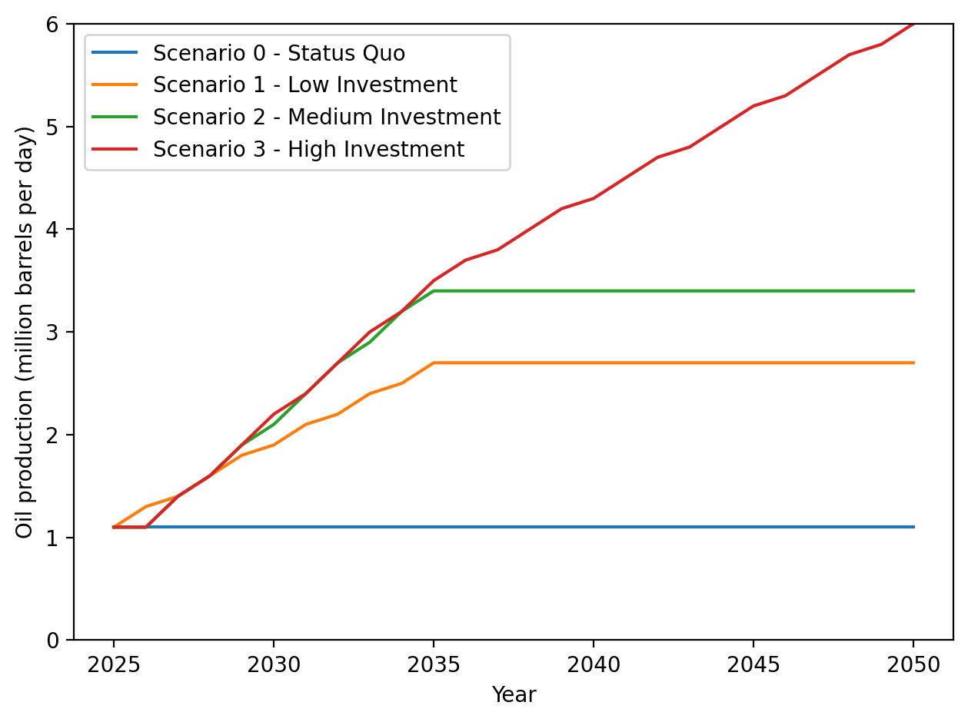
From daily production to total oil output
For each year in each scenario, daily production (in million barrels per day) is converted into annual oil production by multiplying by 365 days and by one million. Adding these annual figures across the period from 2025 to 2050 gives total oil production over the horizon.
In the article, we also distinguish between total production and additional production. Additional production is defined as production above the status quo level of 1.1 million barrels per day. This allows us to isolate the climate impact of expanding Venezuelan production relative to today’s baseline.
From production to cumulative CO₂ emissions
Oil production is converted into carbon dioxide emissions using a constant lifecycle emissions factor of 1.89 tonnes of CO₂ per barrel, applied uniformly across all scenarios. This factor captures both the emissions released when oil is ultimately burned and the additional emissions associated with extraction, upgrading, transport, and refining — which are particularly significant for Venezuela’s heavy crude.
Applying the same emissions factor in each case ensures that differences across scenarios are driven solely by production volumes, rather than by assumptions about technology, efficiency, or fuel composition. For each scenario, we calculate cumulative emissions over the period from 2025 to 2050, as well as the average annual emissions over that horizon. The scenario descriptions in the main text report these average annual values, expressed in gigatonnes of CO₂ per year.
From cumulative emissions to temperature increase
To estimate the warming impact, we rely on the well-established near-linear relationship between cumulative CO₂ emissions and global mean temperature rise. This relationship is known as the Transient Climate Response to Cumulative Emissions of CO₂ (TCRE). This relationship implies that each additional tonne of CO₂ emissions contributes a roughly constant increment to global warming, around 4.5 × 10⁻¹³ °C per tonne of CO₂, or 0.00045 °C per gigatonne, largely independent of when those emissions occur. This relationship underpins the concept of a global carbon budget and is widely used in IPCC assessments.
When the article refers to temperature increases such as “0.01°C between now and 2050”, this reflects the cumulative emissions associated with the production pathway shown in Figure 7, translated using this standard relationship.
Carbon budget shares
We also express cumulative emissions from each scenario as a share of the remaining global carbon budget consistent with limiting warming to 1.5°C. This is done by comparing total emissions from the scenario with an estimate of the remaining budget of around 170 gigatonnes of CO₂.

A carbon budget refers to the total amount of carbon dioxide (CO₂) that can still be emitted globally while keeping global warming below a given temperature threshold (such as 1.5°C above pre-industrial levels), based on the near-linear relationship between cumulative CO₂ emissions and global mean temperature rise.
As such, proved reserves can increase as new reserves are found or existing reserves become economically feasible as economic and technical conditions change. They can also decrease through extraction.
Again based on data from the Energy Institutes’ 2025 Statistical Review of World Energy.
In this way, ‘proved’ reserves differ from ‘probable’ or ‘possible’ reserves, which are those that can be extracted under current economic and technical conditions with at least 50% or 10% probability, respectively.
It is worth recognising that some of the exceptionally high emissions intensities associated with Venezuelan oil today reflect not just the nature of the crude, but the poor state of existing infrastructure in the country. This drives leaks, flaring and inefficiency. Upgrading facilities and capturing methane could reduce upstream emissions even if production stays modest. However, because extra-heavy oil is inherently more energy-intensive to extract and process, these improvements would moderate but not eliminate the carbon-intensity gap with lighter crude sources.
Because both reserves and production respond to prices, technology, investment, and policy, the R/P ratio should not be read as a forecast of when a country will “run out of oil”. The ratio is also mechanically sensitive to production: higher output would reduce it proportionally, so doubling production would halve the R/P figure. The precise number is therefore less important than the underlying message — Venezuela is sitting on a vast stock of oil relative to what it is currently extracting.
Even if the proved reserves figure is overly optimistic and, say, only a third of those barrels were ultimately economic, the implied R/P ratio would still be significantly larger than for other countries.
See ICSID arbitration awards in ConocoPhillips v. Venezuela (ARB/07/30) and ExxonMobil v. Venezuela (ARB/07/27).
In all scenarios, production is anchored at 1.1 million barrels per day in 2025, consistent with recent estimates from industry and official sources, before specifying alternative pathways for how output could evolve thereafter.
However, as this Scenario acts as a baseline, accounting for these factors would only increase later Scenario’s impact on warming and carbon budgets.
Analysis from Rystad Energy suggests that $110 billion in capital expenditure would be required by 2030 to bring the country’s production back to where it was 15 years ago. Achieving and sustaining this trajectory would also require legal certainty for foreign investors and a sustained period of favourable oil prices. These are conditions that recent analysis suggests are difficult, but not impossible, to align.
This is a highly optimistic long-run scenario, requiring sustained high oil prices, massive capital mobilisation, and a global market willing to absorb large additional volumes of heavy crude. These are conditions many analysts view as unlikely to persist simultaneously. However, as some reporting has suggested these levels of production, we have considered the Scenario and calculated the associated warming and carbon budget shares.

